

**PARENT PERMISSION AND WAIVER OF LIABILITY**I hereby approve the participation of __________________________ at the 22nd Annual Summer Youth Swimming and Water Safety Program beginning June 16, 2017 (Orientation Day), then from June 20, 2017 through July 28, 2017. I expressly waive any and all claims against the Youth For Youth LIVE! Guam, Guam Behavioral Health and Wellness Center, Department of Parks and Recreation, the Guam Chamber of Commerce and the other community partners, their respective board members, employees, agents, representatives and successors, arising from or in connection with any accident, injury, illness, or other damage that may be incurred by said child/student or said person's property in connection with or incident to his/her attendance at the 22nd Annual Summer Youth Swimming and Water Safety Program activities. I understand that pictures and/or videos may be taken at the program and hereby agree and consent to the use of these pictures or videos by the organizers for promotional and/or any other purposes.

(Name of Parent/Guardian) (Signature of Parent/Guardian)

(Name of Parent/Guardian) (Signature of Parent/Guardian)

Date: ­ Contact: (Work)

(Home)

(Cell)

*Guam Chamber of Commerce, Department of Parks and Recreation (Hagatna Pool and Tennis Courts), American Red Cross – Guam Unit, and the American Heart Association*



**22nd ANNUAL SUMMER** YOUTH SWIMMING & WATER SAFETY PROGRAM

**June 20 - July 28, 2017**

Hagatña Swimming Pool

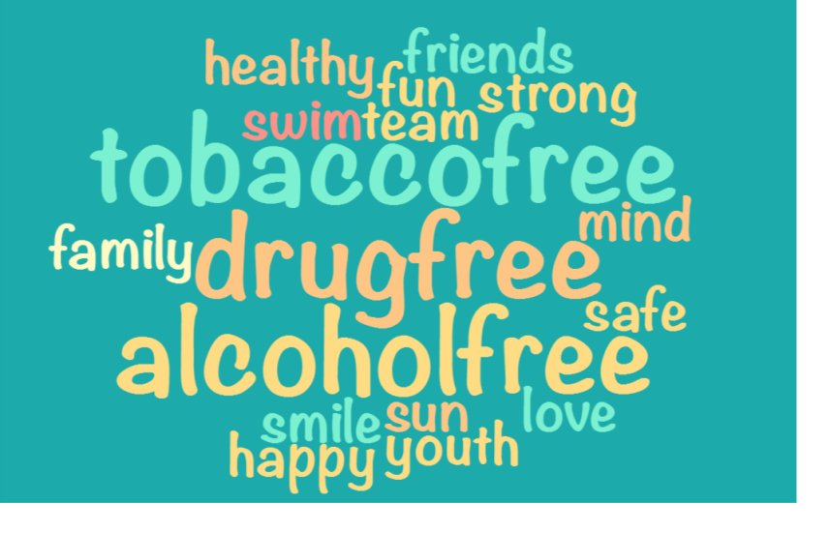

*Si yu’us ma’åse*

Check #______

**REGISTRATION FORM**

**Check One: [ ] SESSION I [ ] SESSION II**

**STUDENT GENDER:**

**NAME: Male [ ] Female [ ]**

**Age: Ethnicity: Village:**

**EMERGENCY CONTACT:**

**NAME: _____ RELATIONSHIP:**

**EMPLOYER: _____**

**EMPLOYER ADDRESS: _____**

**CONTACT NUMBERS: CELL: HOME/WORK: ____ _   
MY CHILD IS A RETURNEE: Y ___ N____**

**MEDICAL INFORMATION: NO YES**

**Are there any physical limitations we should be aware of? ____ ____**

**Does your child have any allergies? ____ ____  
 Describe: _______________________________________**

**Does your child have dietary restrictions? ____ ____  
 Describe: _______________________________________**

**Does your child have any medical conditions? ____ ____  
 Describe: _______________________________________  
 Prescribed medications, if any: ______________________**

**EMERGENCY MEDICAL AUTHORIZATION:**

**I hereby authorize the medical treatment of by any licensed**

**(Name of Participant)**

**physician in the event of medical emergency. My child is covered by**

**(Health Plan/Medical Insurance Co. and Member No.)**

**________________________________________ _____________________________________/______________**

**Print Name (Parent/Guardian Signature Date**

# PROGRAM INFORMATION

**June 16, 2017 – Friday (Orientation Day)**Hours: 8:30 a.m. – 11:30 a.m

Introduction to Program

Assessment of Skill Levels

Parent’s presence is **mandatory** *\* Participants must wear swimsuits*

**June 20, 2017 thru July 28, 2017 (Program Sessions)**

**SESSION I ONLY:** **SESSION II ONLY:**

Days: Tuesdays/Thursdays Days: Wednesdays/Fridays

Hours: 8:00am – 12:00pm Hours: 8:00am – 12:00pm

**July 28, 2017 – (Fiesta Day)**

For all participants (Session I & II) 8:00am – 12:00pm

**OPEN TO AGES: 5 – 15 years**

**REGISTRATION FEE:** **$75.00 per participant** (non-refundable)  
 Checks payable to Youth for Youth LIVE! Guam

|  |  |
| --- | --- |
| ACTIVITIES INCLUDED: | PARTICIPANTS MUST BRING: |
| * Swimming Lessons | * Water bottle |
| * Water Safety Instruction | * Swimwear |
| * Introduction to Tennis | * Extra Clothes |
| * Introduction to First Aid and CPR | * Towel |
| * Drug Prevention/Awareness Presentations | * Sunscreen |
| * Self-Esteem & Team Building Workshops | * Snacks and/or Lunch |
| * Conflict Resolution & Peer Mediation | * Hairbrush/Comb |
| * Tips for Healthy Living | * Plastic bag for wet items |
|  | * Toiletries |

CERTIFIED INSTRUCTORS/VOLUNTEERS:

* American Red Cross/American Heart Association
* Department of Parks & Recreation
* Department of Public Health and Social Services
* GBHWC –Prevention and Training Branch
* Guam Chamber of Commerce
* Guam Army National Guard
* Youth For Youth LIVE! Guam
* Other Community Partners

**For more information, contact:**

**GBHWC Prevention and Training Branch**

**477-9079 thru 9083 or 477-8861/63; Fax 477-9076**